# Java Swing Tutorial

**Java Swing tutorial** is a part of Java Foundation Classes (JFC) that is *used to create window-based applications*. It is built on the top of AWT (Abstract Windowing Toolkit) API and entirely written in java.

Unlike AWT, Java Swing provides platform-independent and lightweight components.

The javax.swing package provides classes for java swing API such as JButton, JTextField, JTextArea, JRadioButton, JCheckbox, JMenu, JColorChooser etc.

### Difference between AWT and Swing

There are many differences between java awt and swing that are given below.

|  |  |  |
| --- | --- | --- |
| **No.** | **Java AWT** | **Java Swing** |
| 1) | AWT components are **platform-dependent**. | Java swing components are **platform-independent**. |
| 2) | AWT components are **heavyweight**. | Swing components are **lightweight**. |
| 3) | AWT **doesn't support pluggable look and feel**. | Swing **supports pluggable look and feel**. |
| 4) | AWT provides **less components** than Swing. | Swing provides **more powerful components** such as tables, lists, scrollpanes, colorchooser, tabbedpane etc. |
| 5) | AWT **doesn't follows MVC** (Model View Controller) where model represents data, view represents presentation and controller acts as an interface between model and view. | Swing **follows MVC**. |

### What is JFC

The Java Foundation Classes (JFC) are a set of GUI components which simplify the development of desktop applications.

### Hierarchy of Java Swing classes

The hierarchy of java swing API is given below.

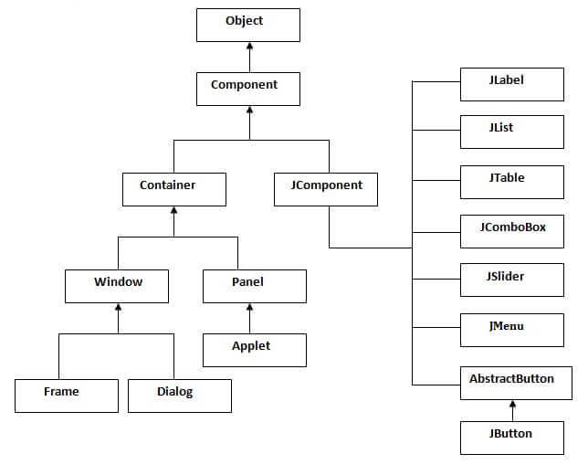

### Commonly used Methods of Component class

The methods of Component class are widely used in java swing that are given below.

|  |  |
| --- | --- |
| **Method** | **Description** |
| public void add(Component c) | add a component on another component. |
| public void setSize(int width,int height) | sets size of the component. |
| public void setLayout(LayoutManager m) | sets the layout manager for the component. |
| public void setVisible(boolean b) | sets the visibility of the component. It is by default false. |

## Java Swing Examples

There are two ways to create a frame:

* By creating the object of Frame class (association)
* By extending Frame class (inheritance)

We can write the code of swing inside the main(), constructor or any other method.

### Simple Java Swing Example

Let's see a simple swing example where we are creating one button and adding it on the JFrame object inside the main() method.

*File: FirstSwingExample.java*

1. **import** javax.swing.*;
2. **public** **class** FirstSwingExample {
3. **public** **static** **void** main(String[] args) {
4. JFrame f=**new** JFrame();//creating instance of JFrame
6. JButton b=**new** JButton("click");//creating instance of JButton
7. b.setBounds(130,100,100, 40);//x axis, y axis, width, height
9. f.add(b);//adding button in JFrame
11. f.setSize(400,500);//400 width and 500 height
12. f.setLayout(**null**);//using no layout managers
13. f.setVisible(**true**);//making the frame visible
14. }
15. }

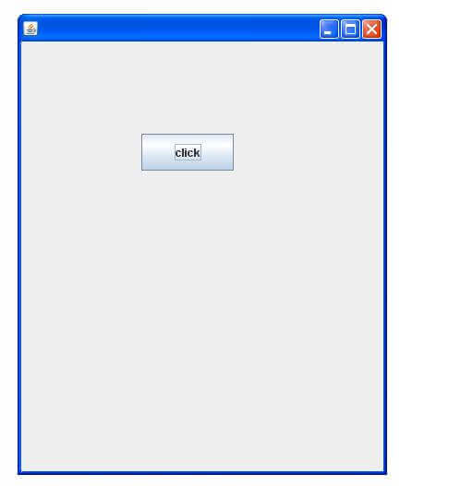

### Example of Swing by Association inside constructor

We can also write all the codes of creating JFrame, JButton and method call inside the java constructor.

*File: Simple.java*

1. **import** javax.swing.*;
2. **public** **class** Simple {
3. JFrame f;
4. Simple(){
5. f=**new** JFrame();//creating instance of JFrame
7. JButton b=**new** JButton("click");//creating instance of JButton
8. b.setBounds(130,100,100, 40);
10. f.add(b);//adding button in JFrame
12. f.setSize(400,500);//400 width and 500 height
13. f.setLayout(**null**);//using no layout managers
14. f.setVisible(**true**);//making the frame visible
15. }
17. **public** **static** **void** main(String[] args) {
18. **new** Simple();
19. }
20. }

The setBounds(int xaxis, int yaxis, int width, int height)is used in the above example that sets the position of the button.

### Simple example of Swing by inheritance

We can also inherit the JFrame class, so there is no need to create the instance of JFrame class explicitly.

*File: Simple2.java*

1. **import** javax.swing.*;
2. **public** **class** Simple2 **extends** JFrame{//inheriting JFrame
3. JFrame f;
4. Simple2(){
5. JButton b=**new** JButton("click");//create button
6. b.setBounds(130,100,100, 40);
8. add(b);//adding button on frame
9. setSize(400,500);
10. setLayout(**null**);
11. setVisible(**true**);
12. }
13. **public** **static** **void** main(String[] args) {
14. **new** Simple2();
15. }}